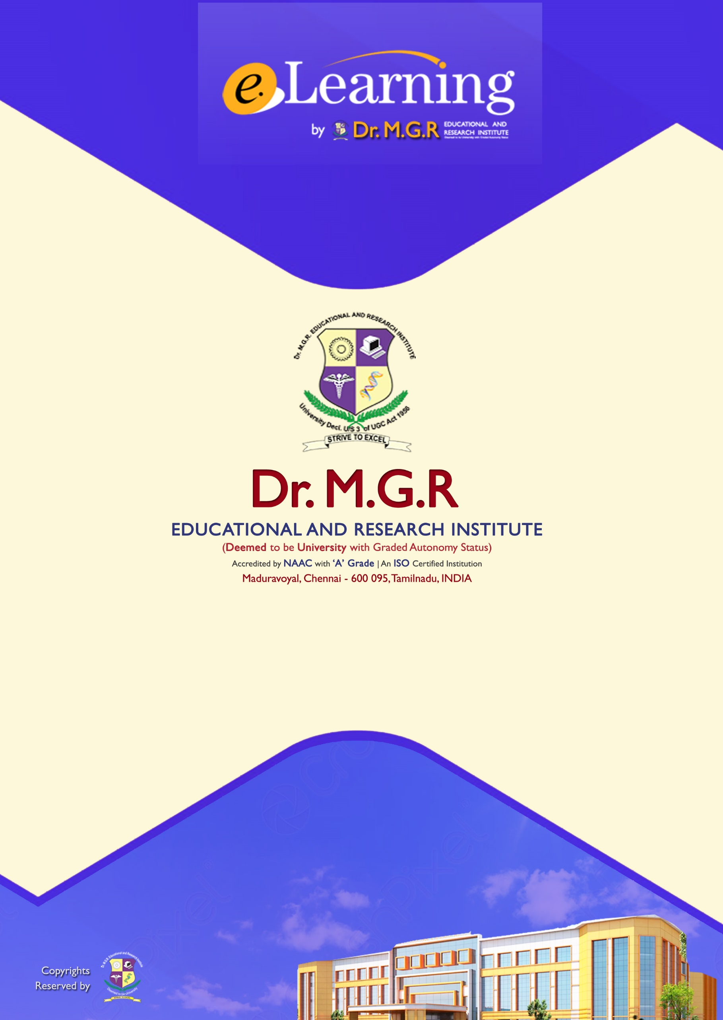

**Topic :** Romanesque Architecture   
**Subject Code :** BAR17009   
**Subject Name :** History of Architecture III  
**Delivered by :** Dr.Vaishnavi S J